**QCFIT USER Guide**

# Installing QCFIT

* Save the setup directory in any desired location.
* And open QCFIT.exe file to launch the application.

## **Input Data Format**

The input data must be in a specific format, as shown in Table 1. The format provides for comma delimiters between values. The format is not stringent to any particular column name.

**Table 1.**

|  |  |
| --- | --- |
| Columns | Description |
| 1 | Date in MM/DD/YY format |
| 2 | Time in HH: MM: SS format |
| 3 | Global horizontal irradiance in W/m2. Missing data are indicated by a value > 8000. |
| 4 | Direct normal irradiance in W/m2. Missing data are indicated by a value > 8000. |
| 5 | Diffuse horizontal irradiance in W/m2. Missing data are indicated by a value > 8000. |

*All time stamps are in local standard time (no adjustment for daylight savings time) and must represent the *ending* time of the integration period.

Example Input Records

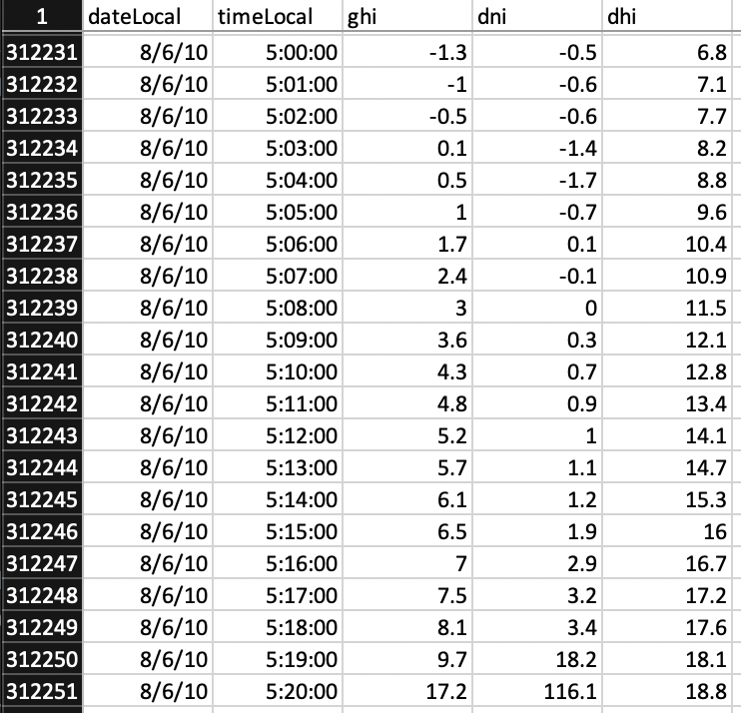

# Working with the Samples

Double-click the QCFIT desktop icon. You should see the QCFIT graphing window.

## Creating a New Site

All site parameters are stored in a **QC-zero** file that is created by the program. Click the file open tool at the left side of the toolbar or select *Open* from the *File* pulldown menu. This displays the Site Open window:

At the right side of the site list drop-down, click the *New Site* button.

For the sample data from the NREL Solar Radiation Research Laboratory, complete each field as shown below:

*Site ID*: SRRL

*Site Description*: NREL

*Latitude*: 39.74

*Longitude*: -105.18

*Time Zone*: -7.0

*Integration*: 1

*Comments*: 1-minute data.

*Integration:* 1

*Plane:* Kt-Kn

*Threshold:* 1

*Elevation:* 1827

Data Folder: This is the folder where the QC0 file (site boundary definition file) will be stored. When the folder is found, click *Ok*.

Click on the Default Data Folder *Browse* button and navigate to the Samples\Sample_data_BMS.csv folder.

[This allows you to set a default folder where the system will look for data files for this station.] Click *OK*.

Click on the New Site *OK* button to create the site. This action returns you to the Open dialog box with the BMS site selected in the Site pulldown list.

## Selecting a Site and Reading Data

The Site pulldown list will contain all sites in the selected folder (there is only one at this time). Other sites may be selected by clicking on the list and highlighting the desired site.

Click on the QCF Files *Browse* button. This will bring up a file browse box pointing to the folder that you chose in the New Site configuration.

Double-click on the file to select it. Click *OK*. This returns to the Open Site dialog box, where the selected file will show beneath the QCF file Browse button.

Select May from the Month list in the lower right of the dialog box. Click the *OK* button to begin reading the data files. Clicking on the *Cancel* button stops the import process.

When the file has been read, the QCFIT graphing window will display plots of the data. An initial set of curves is automatically determined for each new data set.

This plot shows the data in the three air mass regimes and indicates data density by color contours (density key is at below the plots). Data outside the boundaries are shaded in a darker color than data inside the boundaries. The error statistics show quality of fit according to the boundaries that are superimposed on the plot.

## Editing the Curves

Click on the configure button on the center plot (Medium Air Mass). This brings up an editing graph, as shown below.

Here, boundaries can be selected through a variety of methods. Experiment with the Wide and Narrow buttons, Curve and Position controls, and the Less Err and More Err buttons. The statistics describing the fit are updated with each change of the boundary. Set the curves to look like the plot below (Left Curve 4, Position 7; Right curve 1, Position 17).

## Listing and Excluding Data

On the graph window draw a rectangle using mouse (click for initial point and then drag to enlarge the selection)

Click at (40,60) and drag till (60,40) to select few points as done in the above figure.

The points in the rectangle can be excluded or listed. Click the *List* button to bring up a text box showing the data represented by those points.

This will create (in the working directory where QCFIT program is saved) and open a text file and one csv file for the selected data points.

The data points are listed in chronological order, and each point on the plot may represent more than one measurement line.

Now click the *Exclude* button in the control window. This removes the data points from the plot (but not from the input data file).

Multiple selections can be made to remove as many data points as necessary. All excluded data points can be reset at any time by clicking the *Reset* button. The Zoom and home icon on the graph window allow you to zoom in on an area of the plot. Click the *Close* button in the lower right of the Edit window.

## Year Filter

Multiple years are represented in the sample data set. You can highlight selected years in the data plot by using the *Year* pulldown list (above the Low Air Mass plot on the main QCFIT window). Click the pulldown list and select 2018. The plot updates with data from 2018 highlighted in cyan.

Remove the highlighting by left clicking the *Year* pulldown and selecting *All* from the list, or alternatively, by simply right clicking the *Year* pulldown field.

3-Component Filtering

Change the threshold in *3 Component Filtering* box (by default the threshold is set to 1). This filters the data set to remove all data points for which Kt – Kn – Kd is greater than the specified threshold.

Notice how data above the diagonal and other scattered points are eliminated from the plot. The eliminated points have now turned to gray color and the count of active points is reduced but the count of ignored points is increased. To change the threshold, enter a new value in the *Threshold* field (or use the increment/decrement control on the field), then click the *Apply* button to apply the new threshold. To remove filtering, set threshold as 1 and click the Apply button.

## Viewing the Plane Representations

For three-component data, the three different two-dimensional plane combinations of Kt, Kn, and Kd can be plotted. Choose the desired plane by clicking the appropriate *Plane* control button. Clicking the *Animate* button will roll through the three planes in rapid succession. In general, the less movement observed during the animated sequence, the less error among the three components.

Although the three different two-dimensional representations of the data are available, all data are transposed to the Kt/Kn plane for viewing.

## Data Density

Data density is represented by three different distributions, and can be turned off. The key for the data density is displayed under the plots (all three plots are represented by the same density scale).

The three setting of the *Density* controls are described below.

*Off* – All data are represented by one color (dark outside the boundaries and lighter inside the boundaries).

*Equal Freq* – The five different data densities are determined by creating a cumulative frequency distribution of the data frequency for each pixel. The dividing lines between the bins are chosen by the values at equally spaced frequencies. This method tends to mitigate steep gradients in the data densities and helps illuminate density patterns in the data set.

*Equal Range* – The dividing lines between the density bins are determined by dividing the density range into five equal parts. This method tends to display a better representation of the magnitude of the density variability.

*Exponential* – The dividing lines between the density bins are determined by dividing the density range into five bins with the density of each bin being an exponential change from the maximum bin. The *Factor* field allows you to specify the magnitude of the change between bins. For the five bins starting at the most dense bin, subsequent densities are determined as Maximum Density / Factor bin. For example, if Factor is 3 and the maximum density is 300, the dividing lines between density ranges would be 300, 100, 33, 11, and 3. This method allows the user to fine tune the density representation.

The data in earlier examples are shown with the equal frequency representation. The plot below uses the equal range representation. Note that unlike the equal frequency representation, this indicates a very steep density gradient in the upper Kt/Kn area.

## Frequency Distribution

The small plot in the upper center part of the panel shows the frequency distribution of the residual error Kt-Kn-Kd (a perfect three-component measurement would have a residual of zero). This plot is valuable for indicating the range of errors for the data set, as well as any biases.

Although this small plot has no scale, you can double-click the plot to display a larger, more detailed graph:

The residuals are shown within a range of ±0.15 in bins 0.01 wide (the lowest and highest bins include all occurrences outside the range). The vertical axis is frequency for each bin.

The red, green, and blue bars at the bottom of the graph mark the mean errors for each airmass (note the key at the top-right), allowing the analyst to further understand any biases in the data.

## Saving the Boundaries

To save the changes to the boundaries, click the Save icon on the toolbar or use the Save QC0 file from the File pulldown menu. If you exit the program or change data sets, you will be prompted to save or discard changes.

## Changing Data Sets

To process a different month, click the *Month* pulldown list (just above the Year pulldown) and select the desired month. The original data file will be re-read and the desired month’s data extracted. To process a different file, click the File icon on the tool bar or select Open from the File menu.

## Editing the QC0 File

You can change some fields in the QC0 files by selecting the Edit option from the File pulldown menu.

You can edit the white fields shown (the Site ID, which is determined by the file name, is not editable). Click the *OK* button to save the changes.

## Screenshots/ saving image:

Two options exist for or saving the plots and statistics in an optimized format. Images can be saved as either a Windows Bitmap (BMP) file or Portable Network Graphics (PNG) file.

Selecting *Save BMP file* or *Save PNG File* in the File pulldown menu saves the image to a graphics file. The images are saved under “images” folder in the directory where QCFIT is installed.

Output:

Output is a QC0 file in the given format which has the station details like Station name, longitude, latitude, time-zone etc. along with the airmass wise data boundary details in a table for each months and other necessary configuration and data details like integration, plane, data folder, elevation, threshold comments etc.

This is a. general format of the *.QC0 file

Site Identifier: BMS, NREL's SRRL Baseline Measurement System

--- Latitude: 39.7400

-- Longitude: -105.1800

-- Time Zone: -7.0000

---Max Code--- ---Low Airmass---- --Medium Airmass-- ---High Airmass---

KN ----KT----- Left ----Right---- Left ----Right---- Left ----Right----

1 5 15 60 S P S 1 5 15 60 S P S 1 5 15 60 S P S 1 5 15 60

JAN: 90-96/96/00/96; 0-00 0-00/00/00/00; 4-09 1-16/13/00/13; 0-00 0-00/00/00/00

FEB: 88-96/96/00/96; 0-00 0-00/00/00/00; 4-10 1-17/15/00/15; 2-09 2-15/12/00/12

MAR: 85-94/94/00/94; 4-10 1-14/12/00/12; 4-09 2-17/15/00/15; 4-09 1-15/13/00/13

APR: 76-96/96/00/92; 4-10 1-15/15/00/00; 4-09 1-16/14/00/00; 4-13 5-13/13/00/13

MAY: 83-95/95/00/00; 4-09 1-15/15/00/00; 4-09 1-15/14/00/00; 4-09 1-13/13/00/00

JUN: 80-94/94/00/00; 4-09 1-14/14/00/00; 4-09 1-14/14/00/00; 4-09 1-13/13/00/00

JUL: 80-95/95/00/00; 4-09 1-15/14/00/00; 4-09 1-15/14/00/00; 4-09 1-13/13/00/00

AUG: 78-93/93/00/00; 4-09 1-15/14/00/00; 4-09 1-15/14/00/00; 4-08 1-13/12/00/00

SEP: 83-93/93/00/00; 4-09 1-13/12/00/00; 4-09 1-14/13/00/00; 4-08 1-13/12/00/00

OCT: 85-96/96/00/00; 0-00 0-00/00/00/00; 4-09 1-15/13/00/00; 4-08 1-13/11/00/00

NOV: 88-95/95/00/00; 0-00 0-00/00/00/00; 4-09 1-14/13/00/00; 4-08 1-13/12/00/00

DEC: 86-96/96/00/00; 0-00 0-00/00/00/00; 4-09 1-15/13/00/00; 4-08 1-14/13/00/009

DEFAULT CONFIGURATION

Integration (minutes): 1

Data Folder:

Plane: 0 Kt-Kn

3-Component Filter: 1

Elevation: 1827

Comments:

**NOTE:**

With beta release the console is left on intentionally. When you start the application, this console will automatically open and remain alive in the backend. In case of any glitch please take a screenshot and share with us.